**MongoDB Task 1**

For the following question write the corresponding MongoDB queries

1. Find all the information about each products

db.users.find()

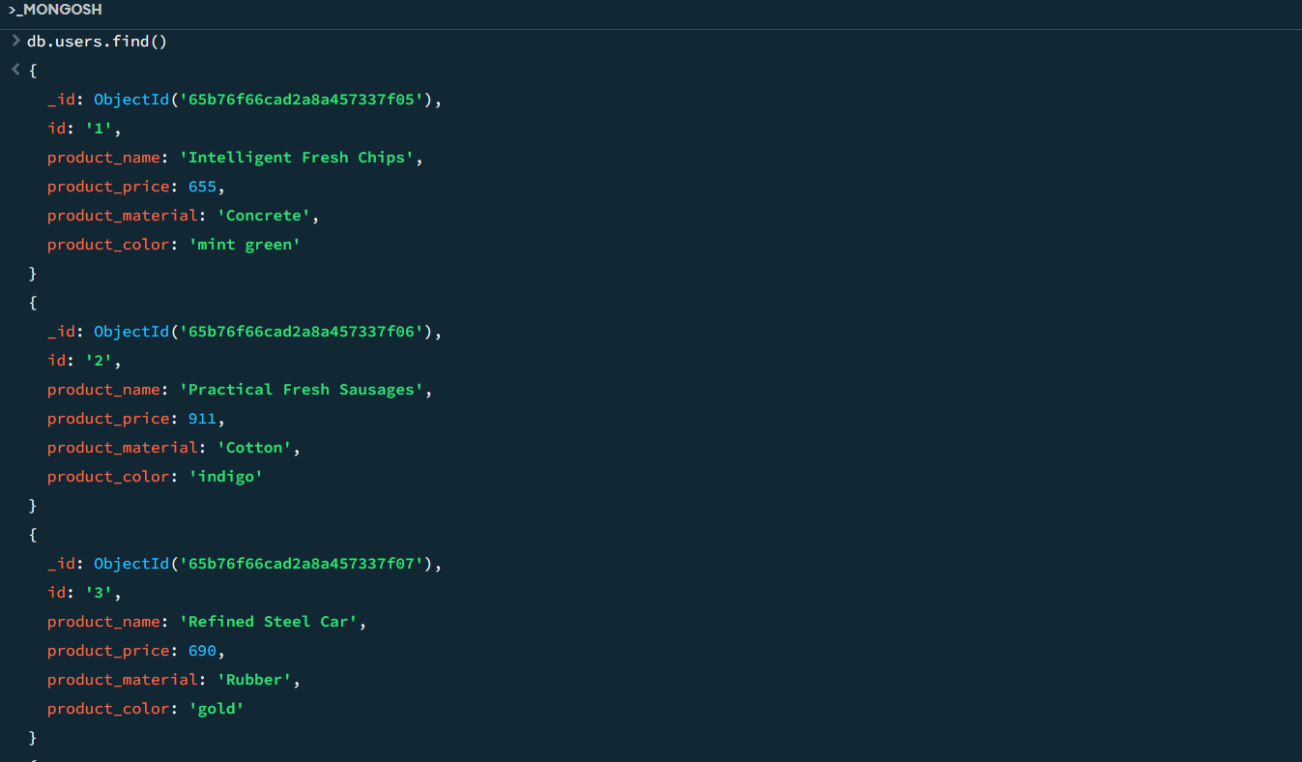

1. Find the product price which are between 400 to 800

db.users.find({$and:[  
{product_price:{$gt:400}},

{product_price:{$lt:800}}

]})

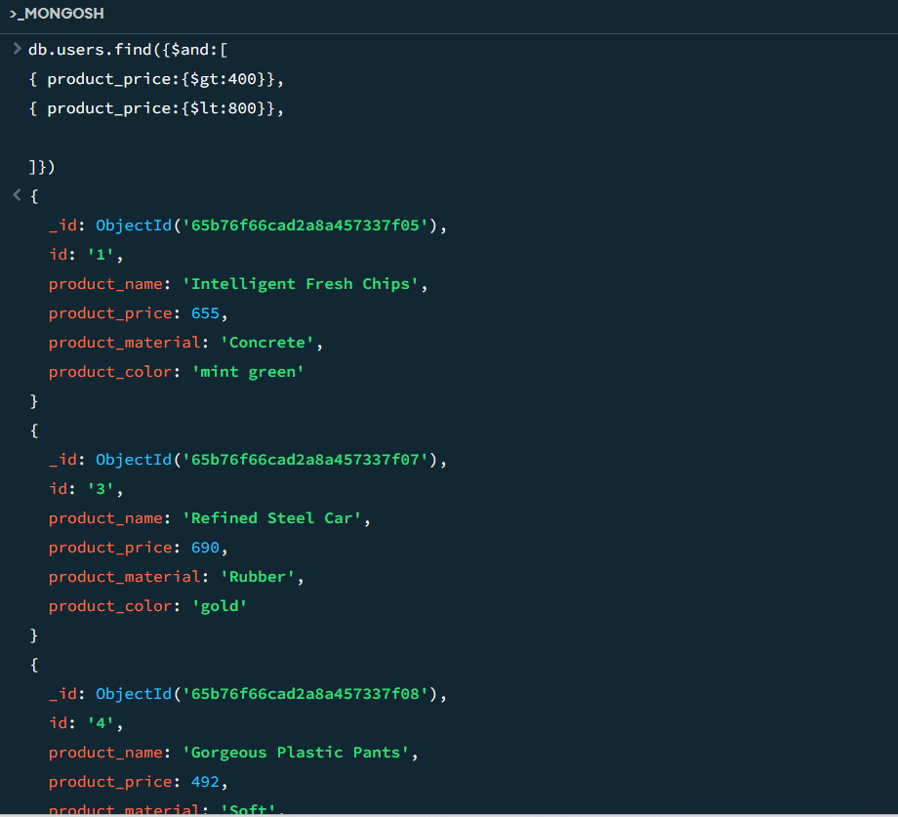

1. Find the product price which are not between 400 to 600

**db.users.find({product_price:{$not:{$gte:400,$lte:600}}})**

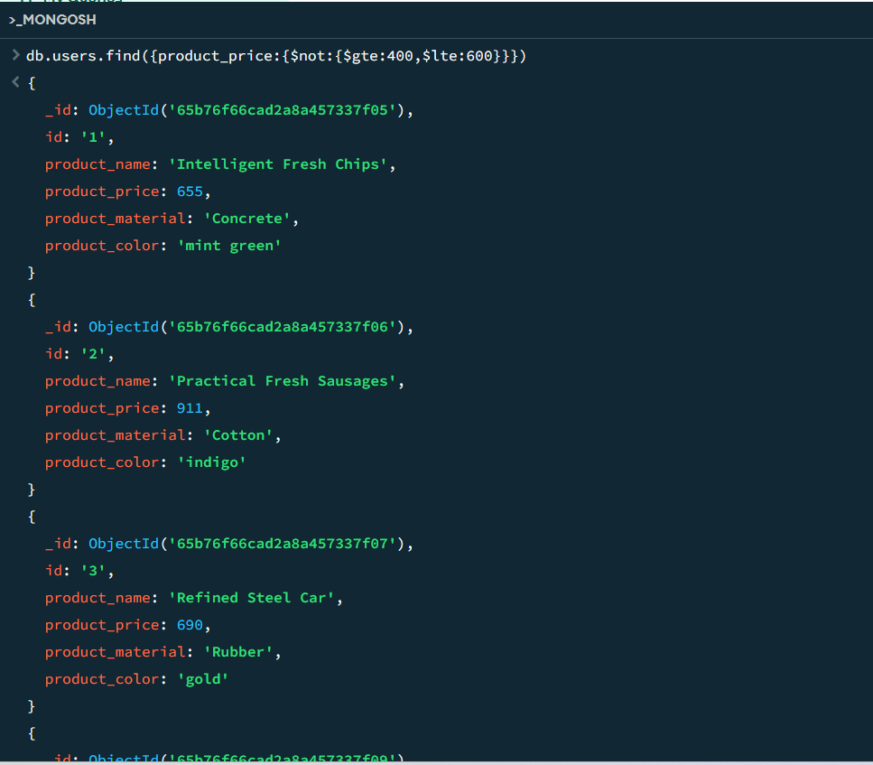

1. List the four product which are grater than 500 in price

db.users.find({product_price:{$gt:500}}).limit(4)

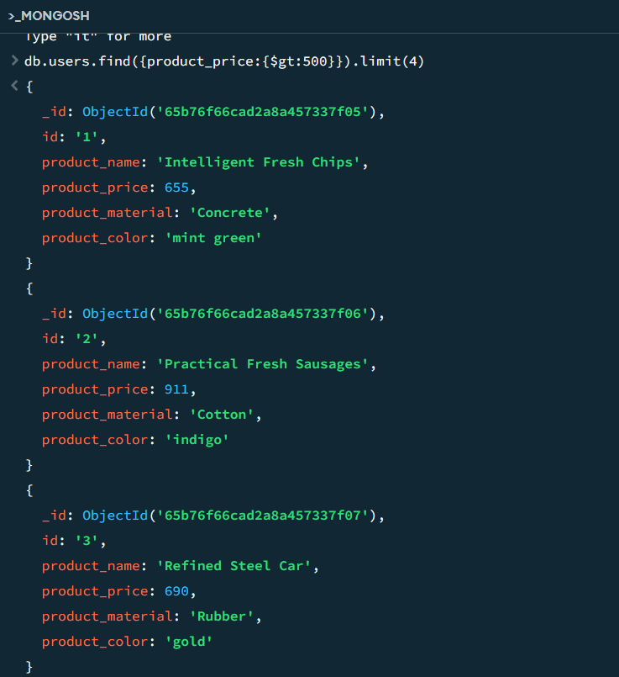

1. Find the product name and product material of each products

db.users.find({},{product_name:1,product_material:1})

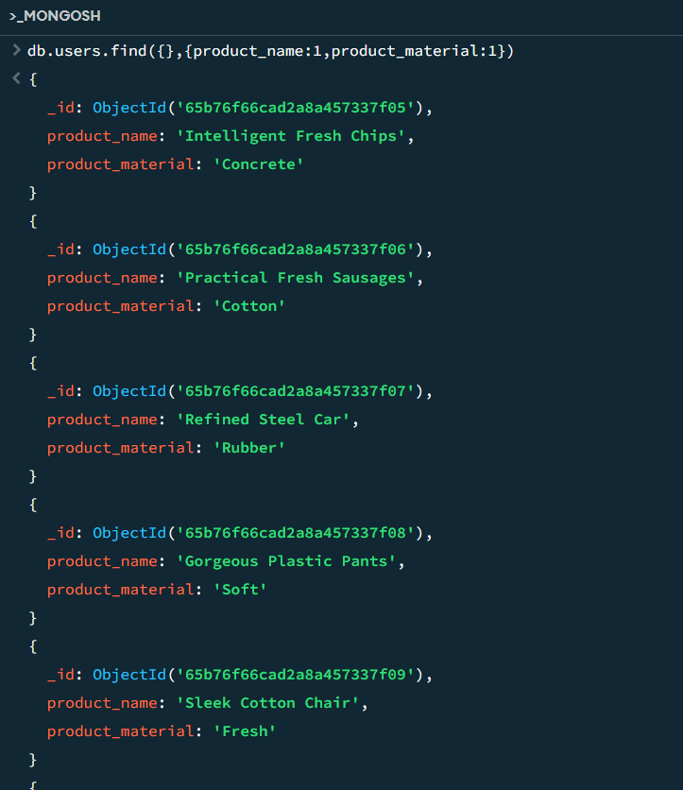

6.Find the product with a row id of 10

db.users.findOne({id:{$eq:”10”}})

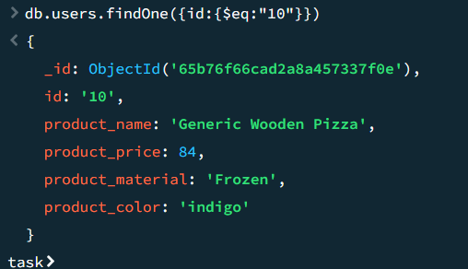

1. Find only the product name and product material

db.users.find({},{product_name:1,product_material:1})

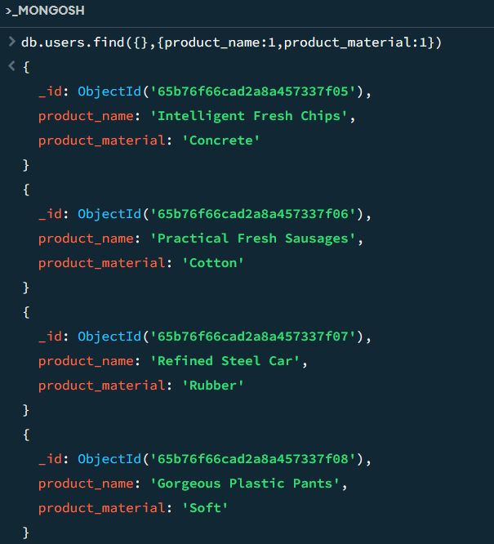

1. Find all products which contain the value of soft in product material

db.users.find({product_material:”Soft”})

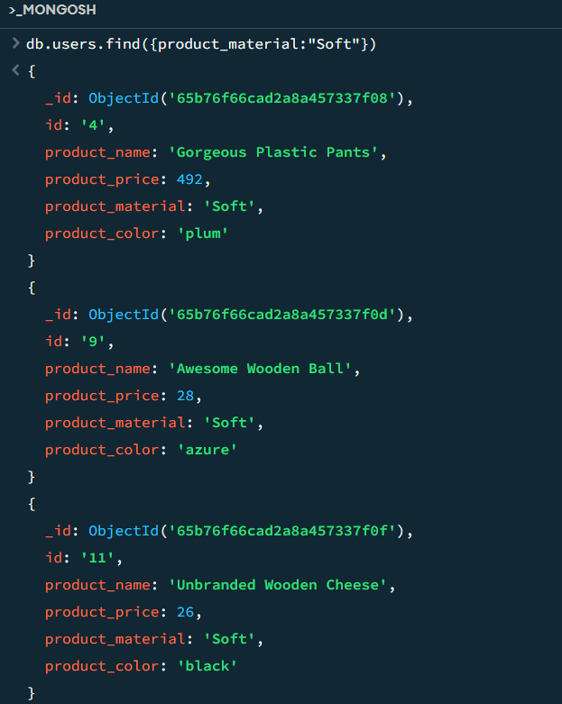

1. Find products which contain product color indigo  and product price 492.00

db.users.find({product_color:"indigo"},{product_price:"492"})

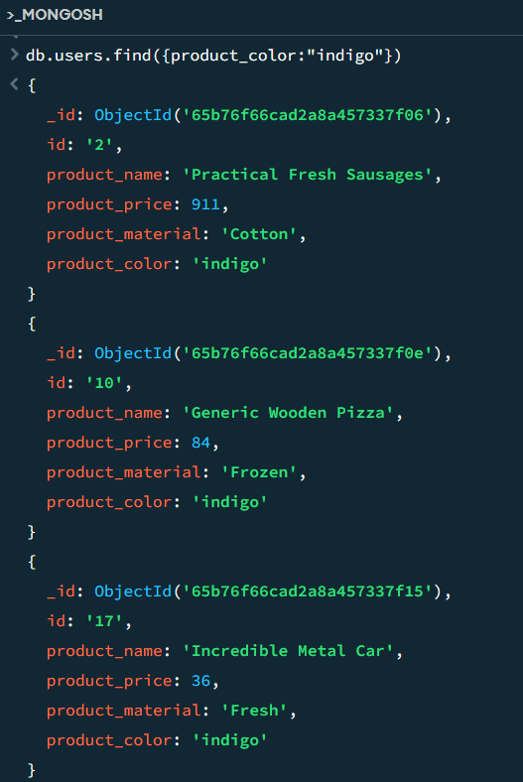

10.Delete the products which product price value are same

db.users.aggregate([{$group:{_id:'$product_price',count:{$sum:1}}}, {$match: {count : {$gt: 1}}}]).forEach((e) => {db.users.deleteMany({product_price: e._id})})